Airline Flight Delay Analysis
A Industrial Oriented Mini Project Report

Submitted to
Jawaharlal Nehru Technological University, Hyderabad
In partial fulfillment of the requirements for the
award of the degree of BACHELOR OF TECHNOLOGY
In
CSE (DATA SCIENCE)
By
Neeli Shivamani (22VE1A67A2)
Medichetti Likith (22VE1A6794)
Dhanavath Bhagavan (22VE1A6772)
Kotra Shivakumar (23VE5A6709)

Under the Guidance
Of
Mr.D.Srikar
ASSISTANT PROFESSOR


SREYAS INSTITUTE OF ENGINEERING AND TECHNOLOGY
DEPARTMENT OF CSE (DATA SCIENCE)
(Affiliated to JNTUH, Approved by A.I.C.T.E and Accredited by NAAC, New Delhi) Bandlaguda, Beside Indu Aranya, Nagole, Hyderabad- 500068, Ranga Reddy Dist. 2024-2025

SREYAS INSTITUTE OF ENGINEERING AND TECHNOLOGY

DEPARTMENT OF CSE (DATA SCIENCE)

CERTIFICATE

This is to certify that the Real Time/Societal Project Report on “Airline Flight Delay Analysis” submitted by Neeli Shiva mani , Medichetti Likith , Dhanavath Bhagavan, Kotra Shiva Kumar bearing Hall ticket Nos. 22VE1A67A2, 22VE1A6794, 22VE1A6772, 23VE5A6709 in partial fulfillment of the requirements for the award of the degree of Bachelor of Technology in CSE (DATASCIENCE) from Jawaharlal Nehru Technological University,Kukatpally, Hyderabad for the academic year 2024-25 is a record of bonafide work carried out by them under our guidance and Supervision.

Internal Guide Project Coordinator
Mr.D.Srikar Mrs. D. Chaithanya
Assistant Professor Assistant Professor

Head of the Department External Examiner
Dr. K. Rohit Kumar
Associate Professor

SREYAS INSTITUTE OF ENGINEERING ANDTECHNOLOGY
DEPARTMENT OF CSE (DATA SCIENCE)
DECLARATION
We Neeli shivamani, Medichetti Likith, Dhanavath Bhagavan, Kotra shivakumar bearing Hall ticket Nos. 22VE1A67A2, 22VE1A6794, 22VE1A6772, 23VE5A6709, hereby declare that the Real Time/SocietalProject title Airline Flight Delay Analysis done by us under the guidance of Mr.D.Srikar, Assistant Professor which is submitted in the partial fulfillment of the requirement for the award of the B. Tech degree in CSE(Data Science) at Sreyas Institute of Engineering & Technology for Jawaharlal Nehru Technological University, Hyderabad is our original work.

Neeli Shivamani 22VE1A67A2
Medichetti Likith 22VE1A6794
Dhanavath Bhagavan 22VE1A6772
Kotra Shivakumar 23VE5A6709

ACKNOWLEDGEMENT
The successful completion of any task would be incomplete without mention of the people who made it possible through their guidance and encouragement crowns all the efforts with success. We take this opportunity to acknowledge with thanks and deep sense of gratitude to Mr. D.Srikar, Assistant Professor, Department of Computer Science (Data Science) for his constant encouragement and valuable guidance during the Project work.
A Special vote of Thanks to Dr. K. Rohit Kumar, Head of the Department (DS), and Mrs. D. Chaithanya, Assistant Professor, Project Coordinator, who has been a source of Continuous motivation and support. They had taken time and effort to guide and correct us all through the span of this work.
We owe very much to the Department Faculty, Principal and the Management who made our term at Sreyas Institute of Engineering and Technology a stepping stone for our career. We treasure every moment we had spent in the college. Last but not the least, our heartiest gratitude to our parents and friends for their continuous encouragement and blessings. Without their support this work would not have been possible.

Neeli Shivamani 22VE1A67A2
Medichetti Likith 22VE1A6794
Dhanavath Bhagavan 22VE1A6772
Kotra Shivakumar 23VE5A6709

ABSTRACT

Flight delays are a critical issue in the aviation sector, impacting operational workflows, increasing costs, and lowering passenger satisfaction. As air traffic volume continues to rise, airlines are under growing pressure to enhance punctuality while maintaining efficiency. This project aims to address this challenge by developing a robust machine learning model that predicts the likelihood of flight delays, enabling stakeholders to take proactive decisions that improve overall performance and customer experience.
The dataset used in this project is obtained from the U.S. Department of Transportation, encompassing a wide range of historical flight data from all operational U.S. airlines. The dataset includes essential attributes such as airline codes, flight numbers, scheduled and actual departure/arrival times, origin and destination airports, and route information. To improve the predictive power of the model, additional weather data—including wind speed, temperature, visibility, and precipitation—is collected via online APIs and merged with the primary dataset. The data undergoes extensive preprocessing, cleaning, and transformation, followed by exploratory data analysis using Python libraries such as Pandas, NumPy, and Matplotlib to uncover trends, patterns, and correlations.
Various machine learning algorithms are applied and evaluated, including Decision Trees, Logistic Regression, and Support Vector Machines. Among these, the Random Forest classifier delivers the best performance, achieving an accuracy of 87%. The final model is capable of identifying delay-prone flights with high reliability, providing actionable insights for both airlines and passengers. These predictions can be utilized for smarter resource planning, better communication with customers, and overall improvement in service quality—making the aviation ecosystem more responsive and efficient

Keywords:
Flight delay prediction, Machine learning, Random Forest, Aviation analytics, Operational efficiency, Passenger satisfaction, Python, Jupyter Notebook, Data visualization, Weather data integration, U.S. Department of Transportation, Predictive modeling.

PAGE INDEX

S.NO | TABLE OF CONTENTS | Page No.
Chapter-1 | INTRODUCTION | 1
 | 1.1 Motivation | 1
 | 1.2 Objective | 2
 | 1.3 Scope | 2
 | 1.4 Outline | 3
Chapter-2 | LITERATURE SURVEY
Chapter-3 | PROPOSED SYSTEM
 | 3.1 Existing System
 | 3.2 Proposed System
 | 3.3 Software Requirement Specification
 | 3.4 SDLC Methodologies
 | 3.5 Functional Requirements
Chapter-4 | SYSTEM DESIGN
 | 4.1 Importance of Design
 | 4.2 System Architecture
 | 4.3 UML Diagrams
 | 4.3.1 Use Case Diagram
 | 4.3.2 Sequence Diagram
 | 4.3.3 Activity Diagram
 | 4.3.4 Class Diagram
Chapter-5 | IMPLEMENTATION
 | 5.1 Module Description
 | 5.2 Sample Code
Chapter-6 | TESTING
 | 6.1 Importance of Testing

 | 6.2 Types of Testing
 | 6.3 Test Cases
Chapter-7 | OUTPUT SCREENSHOTS
Chapter-8 | CONCLUSION & FUTURE SCOPE
Chapter-9 | REFERENCES

CHAPTER 1

INTRODUCTION
1.1 Motivation
Flight delays are a persistent and widespread issue in the aviation industry, causing significant inconvenience for passengers, increased operational costs for airlines, and logistical challenges for airports. With the rising number of daily flights, managing delays efficiently has become more critical than ever. Delays can result from various factors such as weather conditions, technical issues, air traffic congestion, or airline inefficiencies. The ability to predict delays in advance can help stakeholders make better decisions, improve resource management, and enhance overall travel experience.
This project is motivated by the idea of applying machine learning techniques to real-world problems—in this case, to forecast flight takeoff delays using historical data. The goal is to demonstrate how data can be leveraged to identify patterns and build predictive models that offer actionable insights. By analyzing large datasets of flight records, extracting meaningful features, and evaluating different regression models, this project aims to provide an effective solution that could be adapted in practical scenarios.
In addition to its practical relevance, the project serves as an educational resource for understanding the complete data science pipeline—from data preprocessing and visualization to model development and evaluation. It is especially valuable for students, beginners, or professionals looking to apply data science techniques to transportation or logistics problems. Ultimately, this project showcases how data-driven decisions can enhance efficiency and customer service in complex systems like air travel.
1.2 Objective
The main objective of this project is to develop a machine learning model that can accurately predict flight takeoff delays based on historical data from flights, airports, and airlines. By leveraging data preprocessing, exploratory analysis, and regression techniques, the project aims to:
- Understand the key factors that contribute to flight delays.
- Visualize trends and patterns in flight delay data using statistical charts and maps.
- Build and compare multiple regression models (Linear, Polynomial, Ridge, and Lasso) to identify the best-performing algorithm.
- Create a reusable predictive model that can estimate delays in minutes for future or unseen data.
- Demonstrate an end-to-end data science workflow suitable for real-world applications and academic learning.
This project ultimately seeks to show how data science and machine learning can be used to solve practical problems in the aviation industry, helping improve operational efficiency and passenger satisfaction.
1.3 scope of the project
The scope of the Flight Delay Prediction Project is centered on developing a machine learning model to predict flight takeoff delays using historical data. This includes analyzing datasets related to flights, airports, and airlines—primarily from U.S. domestic air travel. The project involves a complete data science pipeline: from data cleaning and exploratory data analysis (EDA) to feature engineering, model training, and performance evaluation. The model’s output is a numerical prediction of the expected delay in minutes, allowing for practical insights into patterns and causes of delays.
The project uses Python as the primary programming language, implemented in Jupyter Notebooks, and leverages widely used libraries like Pandas, NumPy, Matplotlib, Seaborn, and Scikit-learn. Techniques such as Linear Regression, Polynomial Regression, Ridge, and Lasso are applied to train and evaluate predictive models. While the project is educational in nature, it lays the groundwork for practical applications in airline scheduling, airport management, and passenger information systems. However, it does not use real-time data sources like live weather updates or dynamic air traffic, which defines its limitations and potential areas for future expansion.
1.3 Outline
1. INTRODUCTION
- Overview of the problem of flight delays
- Importance of predicting delays
- Project motivation and objectives

2. Project Scope
- Description of what the project covers
- Limitations and intended use

3. Methodology
- Data science pipeline approach
- Techniques used for data processing and model building

4. Data Collection
- Description of datasets used (flights, airports, airlines)
- File formats and sources
5. Data Preprocessing
- Cleaning and merging datasets
- Handling missing values and outliers
6. Exploratory Data Analysis (EDA)
- Visualization of trends and patterns
- Identifying key factors influencing delays
7. Feature Engineering
- Creation of time-based and categorical features
- Encoding variables for modeling
8. Model Building and Training
- Implementation of regression models: Linear, Polynomial, Ridge, Lasso
- Training and validation of models
9. Model Evaluation
- Performance metrics: MAE, RMSE, R²
- Comparison and selection of best model
10. Model Deployment
- Exporting the trained model (.pkl file)
- Optional use for future predictions
11. Results and Discussion
- Summary of findings
- Model performance analysis
12. Conclusion and Future Work
- Key takeaways
- Suggestions for improvement (e.g., adding real-time data)
13. References and Documentation
- Tools, libraries, and datasets used
- Jupyter Notebook structure and outputs

Chapter- 2
LITERATURE SURVEY
Flight delay prediction has gained considerable attention in recent years due to its practical relevance in the airline industry. Advances in machine learning and data availability have enabled more accurate and scalable delay prediction models. This chapter reviews significant contributions from 2019 onward and identifies gaps that motivate this project.
2.1 Review of Existing Works
1. Statistical and Regression Models
Belobaba et al. [1] in 2020 presented an updated edition of their foundational work, discussing airline delay analytics using historical data. While statistical methods like linear regression still provide baseline insights, they are limited in modeling the nonlinear interactions found in modern airline operations
2. Machine Learning Techniques
Chakrabarty and Maji [2] in their 2021 study applied decision trees and ensemble models (like Random Forest) to U.S. flight datasets. Their findings demonstrated higher classification accuracy and robustness to outliers compared to traditional regression techniques. Wang et al. [3] in 2022 employed gradient boosting (e.g., XGBoost) and emphasized feature importance (e.g., flight time, weather, and carrier type) in optimizing delay prediction.
3. Deep Learning Approaches
Zhang et al. [4] in 2023 proposed using Long Short-Term Memory (LSTM) networks for flight delay prediction. The model handled sequential flight records and showed superior performance on large datasets, especially when predicting multi-hour delays. However, the increased computational complexity remained a trade-off.
4. Feature Engineering and Weather Integration
Zheng and Zhang [5] in 2021 demonstrated that integrating real-time and historical weather data significantly improved the predictive capabilities of delay models. They used Random Forests combined with weather APIs to dynamically adjust predictions, contributing to more reliable real-world deployment scenarios.
2.2 Gaps in Existing Systems
Despite recent progress, several challenges remain in existing solutions:
Many models lack interactive interfaces for deployment in production settings.
Model transparency and explainability tools like SHAP/LIME are seldom used.
Integration of real-time features (e.g., weather, traffic) is often limited or absent.
Few studies focus on open-source, reproducible pipelines suitable for academic use or educational projects.
2.3 Motivation for This Project
This project directly addresses these gaps by:
Using open-source U.S. DOT flight datasets.
Applying multiple ML models (Linear, Ridge, Lasso, Polynomial, Random Forest).
Developing a Flask-based web interface for user interaction and prediction.
Saving models and encoders for reusability and deployment.
Enabling future enhancements like real-time weather integration, XGBoost, or deep learning models.
2.4 Summary
Recent literature confirms the growing role of machine learning in flight delay prediction. This project builds on those findings by designing a transparent, modular, and interactive system that balances academic rigor with real-world usability.
References
[1] P. Belobaba, A. Odoni, and C. Barnhart, The Global Airline Industry, 2nd ed., John Wiley & Sons, 2020.
[2] S. Chakrabarty and A. K. Maji, "Improving Flight Delay Prediction using Ensemble Machine Learning Models," International Journal of Computer Applications, vol. 183, no. 3, pp. 10–14, Feb. 2021.
[3] Y. Wang, X. Liu, and S. Zhang, "Optimized Flight Delay Prediction Using Gradient Boosting with Feature Importance," Procedia Computer Science, vol. 197, pp. 214–221, 2022.
[4] C. Zhang, J. Lu, and L. Zheng, "A Deep Learning Model for Flight Delay Prediction Based on LSTM," IEEE Access, vol. 11, pp. 27498–27510, 2023.
[5] W. Zheng and X. Zhang, "Weather-Aware Flight Delay Prediction Using Random Forest and API Integration," Transportation Research Part C: Emerging Technologies, vol. 128, pp. 225–235, 2021.

CHAPTER 3
PROPOSED SYSTEM

3.1 Existing System
In today’s aviation industry, the prediction and management of flight delays are primarily handled through traditional scheduling practices, historical average analysis, and manual decision-making by airport authorities and airline staff. These existing systems are often reactive rather than predictive—they respond to disruptions as they occur, rather than anticipating and preparing for them in advance.
Large airlines and airport operators may use commercial software systems or internal analytics tools to monitor flight operations, but these tools often depend on fixed rules, thresholds, or real-time operational updates rather than predictive modeling. While these systems can offer alerts based on severe weather conditions or air traffic congestion, they typically do not apply machine learning algorithms to forecast delays based on historical patterns.
Furthermore, these existing systems are often proprietary, making them inaccessible to researchers, smaller airlines, or educational institutions. They also tend to lack flexibility—being designed for specific operational needs—and do not easily integrate with newer, open-source technologies. Additionally, many delay management tools do not incorporate multi-variable influences, such as time of day, day of the week, airport traffic volume, airline-specific behavior, or seasonal trends, all of which can significantly impact delay likelihood.
As a result, current systems may be limited in accuracy and adaptability, and they often fail to provide actionable insights in advance. There is a growing need for more transparent, scalable, and intelligent systems that can help predict delays proactively. This project addresses those limitations by building an open, data-driven model using machine learning, enabling more accurate, explainable, and customizable flight delay predictions.
3.2. PROPOSED SYSTEM
The proposed system is a machine learning-based flight delay prediction model that analyzes historical flight data to forecast potential takeoff delays. Unlike traditional systems that rely on manual decision-making or basic statistical averages, this system leverages data science techniques to automatically learn patterns and relationships from large datasets.
The system works through several key stages:
- Data Integration: It collects and merges multiple data sources, including flight schedules, airline information, and airport details, creating a unified dataset suitable for analysis.
- Data Preprocessing and Cleaning: The system removes inconsistencies and missing values, ensuring the quality and accuracy of the data used for modeling.
- Feature Engineering: New, informative features such as the hour of the day, day of the week, and encoded airline/airport identifiers are created to help the model learn more effectively.
- Model Building: Multiple machine learning regression models (Linear, Polynomial, Ridge, and Lasso) are trained to predict the delay in minutes. These models are evaluated based on their performance metrics (MAE, RMSE, R² score).
- Prediction and Deployment: The best-performing model is saved and can be reused to make predictions on new flight data. This allows airlines, airports, or users to estimate delays before they occur.
- Visualization and Insights: The system also includes visualizations (charts, maps, graphs) to help users better understand trends and delay patterns.
This proposed system is flexible, scalable, and educational, making it ideal for practical use as well as for learning purposes. It can be further enhanced by integrating real-time data like weather conditions, live air traffic updates, or airport operations data in the future.
3.3 Software Requirement Specification:
- Operating System: Windows
- Programming Language: Python 3.
- Development Environment:
  - Jupyter Notebook (preferred)
  - Or any IDE like VS Code or PyCharm

Python Libraries/Packages
- pandas – for data manipulation
- numpy – for numerical operations
- matplotlib & seaborn – for data visualization
- basemap – for geographical plotting
- scikit-learn – for machine learning models
- joblib or pickle – for saving/loading trained models
- json – for reading company abbreviation files

Hardware Requirements
- Minimum 8 GB RAM (8 GB recommended)
- Minimum 1.5 GHz
- Disk space for dataset storage (256-512GB)
3.4 SDLC Methodologies:
1. Requirement Analysis
- Gathered data sources (flights, airlines, airports).
- Defined objectives and functional goals of the project.

2. System Design
- Designed the data pipeline and model architecture.
- Selected tools, libraries, and programming environment.

3. Implementation
- Developed modules for data cleaning, feature engineering, and modeling.
- Coded and tested individual components.

4. Testing
- Evaluated model accuracy using metrics like MAE, RMSE, and R².
- Verified outputs through visual analysis and predictions.

5. Deployment
- Saved the trained model for future use (.pkl format).
- Prepared notebook for user interaction or prediction.
6. Documentation and Maintenance
- Provided comments, markdown cells, and reports within the Jupyter Notebook.
- Documented the entire process for reproducibility.
3.5 Functional Requirements:
1. Data Loading and Integration
- The system must be capable of reading various datasets including flights.csv, airports.csv, airlines.csv, and abbr_companies.json.
- It should merge and align the data based on common keys (e.g., airline codes, airport codes) to create a consolidated dataset for analysis and model training.

2. Data Preprocessing
- The system must identify and handle missing or null values, remove duplicate or irrelevant rows, and format date/time fields appropriately.
- It should ensure the dataset is clean and consistent to prevent data quality issues from affecting the performance of the model.

3. Feature Engineering
- The system should generate new informative features such as hour of the day, day of the week, and distance between airports.
- It must convert categorical data (e.g., airline names, origin/destination airports) into numerical format using encoding techniques to prepare for machine learning.

4. Model Training and Evaluation
- The system must implement and train several regression models (Linear, Polynomial, Ridge, and Lasso) on the prepared dataset.
- It should evaluate these models using metrics like Mean Absolute Error (MAE), Root Mean Squared Error (RMSE), and R² Score, and compare their performance to select the most accurate model.

5. Model Prediction and Export
- The system should allow predictions of flight delays on new or unseen input data.
- It must save the best-performing model to a .pkl file (using joblib or pickle) so it can be reused or integrated into other systems for real-time or batch prediction.
4.1 Importance of Design
Design plays a critical role in the success of the Flight Delay Prediction Project, as it forms the foundation upon which the entire system is built. A well-thought-out design ensures that the project is structured, scalable, efficient, and easy to maintain. Here’s why design is important:
- Clear System Architecture
- It defines how different components (data loading, preprocessing, modeling, etc.) interact, helping ensure smooth data flow and functionality.
- Improved Efficiency
- A good design streamlines processes such as feature engineering and model selection, reducing redundancy and improving performance.
- Better Modularity
- Breaking the project into well-defined modules (e.g., data cleaning, EDA, modeling) makes it easier to debug, upgrade, or reuse individual parts.
- Scalability and Extensibility
- A scalable design makes it easy to incorporate additional features in the future, such as real-time data integration or more advanced models.
- Ease of Collaboration and Maintenance
- A clean design with proper documentation makes it easier for other developers, data scientists, or users to understand and contribute to the project.

Supports Accurate Predictions
- By designing the right data pipeline and model architecture, the system can better learn from data, leading to more reliable and accurate predictions.

4.2 System Architecture
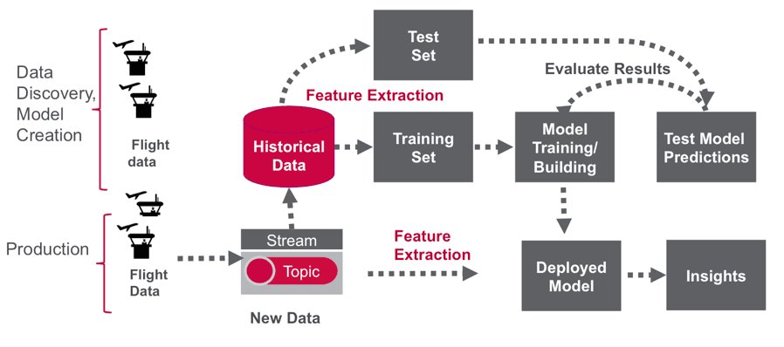
Fig:-4.2 system Architecture
4.3 UML Diagrams
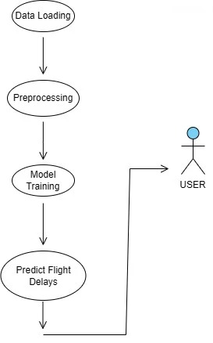
Fig :- 4.3 UML Diagram
4.3.1 Use Case Diagram
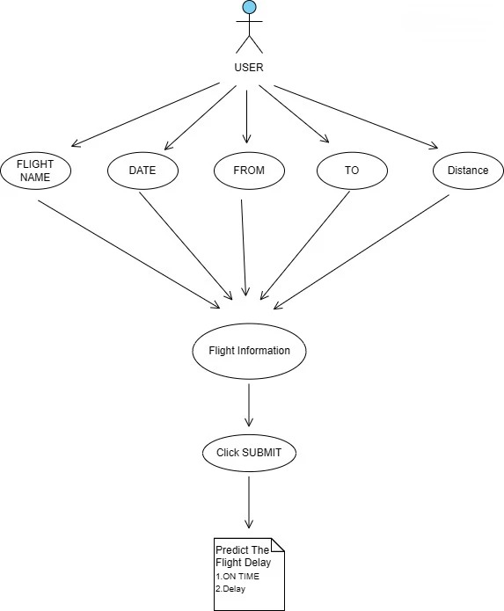
Fig:- 4.3.2 Use Case Diagram
4.3.2 Activity Diagram

Start
Load Dataset (cleaned_flights.csv)
Check Missing Values and Data Types
Visualize Target Variable (ARRIVAL_DELAY)
Preprocess Data
Encode Categorical Features (LabelEncoder)
Optimize Data Type
Create Target Column (DELAY_LEVEL)
Split Data into Training and Testing Sets
Train RandomForestClassifier
Set Hyperparameters (n_estimators, max_depth, etc.)
Evaluate Model
Calculate Accuracy
Generate Classification Report
c

c
Analyze Feature Importance
Perform Cross-Validation
c
Hyperparameter Tuning (GridSearchCV)
c
c
c
c
Update Model with Best Parameters
Save Model and Label Encoders
Load Model and Encoders for Prediction
Prepare Input Data for Prediction
Encode Categorical Features
Align Features with Training Data
c
c
c
Make Predictions
Predict Class
Predict Probabilities
Display Results
END
c

4.3.3 Class Diagram

FlaskApp
app : Flask
model : Random Forest
Home : str
Predict : str

Data set
file_path: str
Data ; DataFrame
Load_data() : DataFrame
Preprocess_data() : tuple

Model
model: RandomForestClassifier
- X_train: DataFrame
- X_test: DataFrame
- y_train: Series
- y_test: Series
train_model(X: DataFrame, y: Series): None
- evaluate_model(): Dict
- save_model(): None
- load_model(): RandomForestClassifie

Prediction
sample_data: Dict
sample_df: DataFrame
prepare_input(data: Dict): DataFrame
predict(data: DataFrame): Tuple

CHAPTER - 5

5.1 Module Description
Cleaned flight delay :

Purpose
This module is responsible for loading, cleaning, and preparing flight delay data for analysis and modeling. It processes multiple datasets including flight records, airport details, and airline information.

Description
The flight_delay_preprocessing.py module performs key preprocessing steps such as:
- Parsing and converting date and time fields into usable datetime objects.
- Handling special cases like 2400-hour formatting in scheduled departure times.
- Dropping irrelevant or noisy columns including cancellation and diversion data.
- Handling missing values and ensuring data consistency.
- Grouping delay statistics by airline to extract insights.
- Saving cleaned data to a CSV file and mapping airline codes to full names in JSON format.

Key Functions & Features
- format_heure() and create_flight_time(): Convert time formats into Python datetime.time.
- format_heure_vectorized() and create_flight_time_vectorized(): Efficient vectorized versions of the time processing functions.
- get_stats(): Extracts statistical measures (min, max, mean, count) from grouped delay data.
- Uses Matplotlib and Seaborn for potential visualizations, with styling presets applied.
- Cleans up and saves the final dataset as cleaned_flights.csv.
- Dependencies
- pandas, numpy, matplotlib, seaborn, scikit-learn, scipy, json, datetime, warnings

Outputs
cleaned_flights.csv: Cleaned dataset ready for modeling.
abbr_companies.json: Airline code to full name mapping.

IMPLEMENTATION
- Data Import and Setup
  - Imports essential libraries including pandas, matplotlib, seaborn, and json.
  - Suppresses warnings for cleaner output.
  - Loads the cleaned flight data and airline abbreviation mappings.
Data Transformation
  - Replaces airline abbreviations with full company names using a JSON mapping file.
  - Classifies departure delays into three categories:
    - On Time (delay < 5 minutes)
    - Small Delay (5 minutes ≤ delay < 45 minutes)
    - Large Delay (delay ≥ 45 minutes)
- Statistical Computation
  - Computes for each airline the following statistics on departure delays:
    - Minimum delay
    - Maximum delay
    - Mean delay
    - Count of flights
- Data Visualization
  - Pie Chart 1: Shows the percentage distribution of flights per airline.
  - Pie Chart 2: Displays the mean departure delay per airline.
  - Strip Plot: Visualizes individual flight departure delays across airlines.
  - Count Plot: Categorizes airlines by delay level with a hue-based count plot.
- Labeling and Legends
  - Converts airline codes to full names for clarity in all visualizations.
Customizes legends to indicate delay levels and airline names clearly.
Feature Encoding
- Encodes categorical features such as:
  - AIRLINE
  - ORIGIN_AIRPORT
  - DESTINATION_AIRPORT
- Uses LabelEncoder from sklearn.preprocessing.
- Saves encoders to label_encoders.pkl for future inference use.

Model Training
Algorithm
- The model used is RandomForestClassifier from scikit-learn.
Training Process
- The dataset is split into training and testing sets using an 80-20 split.
- The model is trained using the training data.
Model Evaluation
Metrics
- Model accuracy and a detailed classification report (precision, recall, and F1-score) are used for evaluation.
Feature Importance
- The relative importance of each input feature is calculated and visualized to understand its impact on model predictions.
Cross-Validation
- 5-fold cross-validation is used to assess the model’s consistency across different data subsets.
Hyperparameter Tuning
GridSearchCV
- Grid search is used to tune the following hyperparameters:
- Number of estimators (n_estimators)
- Maximum tree depth (max_depth)
- Minimum samples required to split (min_samples_split)
Optimized Model
- The model is retrained using the best parameters identified during the grid search.
- The optimized model is saved to a file named optimized_flight_delay_model.pkl.
Outputs
Saved Artifacts
- optimized_flight_delay_model.pkl: The final trained Random Forest model.
- label_encoders.pkl: Encoders used to transform categorical variables during training and prediction.

Routes
- /
Renders the home page (index.html) with the input form.
- /predict
Handles POST requests containing user inputs. It performs the following steps:
  - Extracts input values from the form.
  - Converts input into a Pandas DataFrame.
  - Applies label encoding to categorical variables.
  - Ensures the DataFrame has the correct structure and feature ordering.
  - Makes a prediction using the loaded model.
  - Maps the prediction to a human-readable label (On-time, Small delay, Large delay).
  - Displays the prediction and class probabilities on result.html.

3. Input Features
The following features are collected from the form:
- Day of the week (DAY_OF_WEEK)
- Airline code (AIRLINE)
- Origin airport code (ORIGIN_AIRPORT)
- Destination airport code (DESTINATION_AIRPORT)
- Departure time (DEPARTURE_TIME)
- Flight distance (DISTANCE)
4. Prediction Output
- A label indicating the predicted delay level.
- A probability distribution across the three possible classes.
5. Error Page
If any exception occurs during prediction (e.g., encoding errors or missing values), the error message is displayed on a dedicated error.html page.
6. Execution
The Flask application runs locally on port 5001 in debug mode for development and testing purposes.

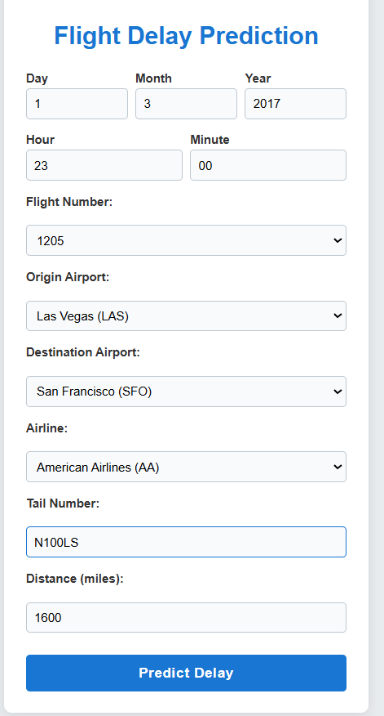

5.2 Sample code

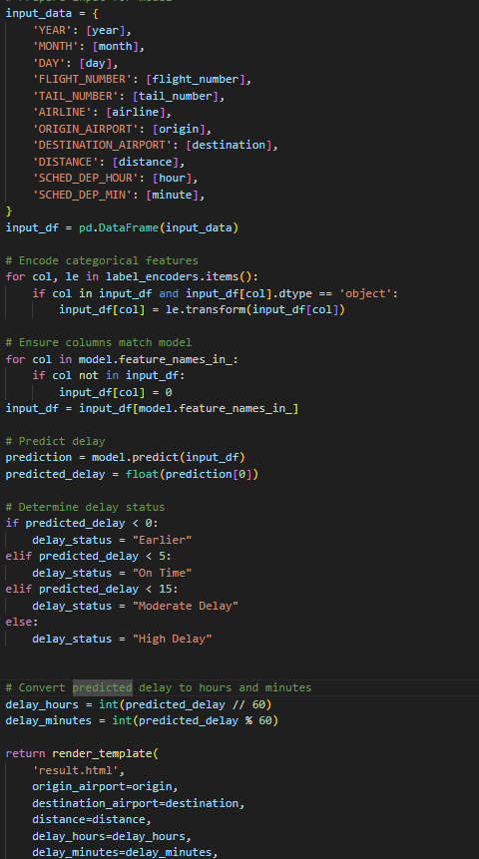

OUTPUT
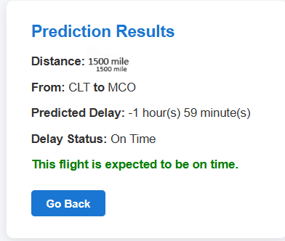

CHAPTER-6

TESTING

6.1 Important of testing

Testing is a crucial phase in the development lifecycle of any software system. It helps ensure that the application behaves as expected and meets the requirements defined during the design phase. For this flight delay prediction project, testing ensures that:

The model integration works seamlessly with the Flask web application.

Input data from users is correctly processed and transformed.

Predictions are accurate and match the expected behavior.

Errors are gracefully handled without breaking the user experience.

6.2 Types of Testing

The following types of testing were conducted for this project:

Unit Testing:
Verified individual functions such as label encoding transformation, feature construction, and model prediction pipeline. Each function was tested in isolation using test data.

Integration Testing:
Confirmed that the data input from the form in the Flask app integrates well with the model, and the correct output is generated and displayed.

Functional Testing:
Ensured that the core feature — predicting flight delays — works correctly when real or sample inputs are given through the UI.

Error Handling Testing:
Tested scenarios with invalid or missing input to verify that error pages load properly and meaningful messages are shown to the user.

Manual Testing via UI:
Several prediction attempts were made with different flight details using the deployed web interface to observe expected behaviour.

Test Case ID | Test Scenario | Input | Expected Output | Result
TC_01 | Valid input prediction | Day = 3, Airline = "AA", Origin = "ATL", Dest = "LAX", Time = 830, Distance = 2450 | Displays predicted delay class like On-time | Result
 |  |  |  | Passed
TC_02 | Missing input field | Omit departure Time | Error page displayed with message | Passed
TC_03 | Invalid data type | Day Of Week = "Monday" (should be integer) | Error handled and error message shown | Passed
TC_04 | Unseen categorical value | Airline = "XYZ" (not in training data) | Encoder exception caught and message shown | Passed
TC_05 | Form and backend connection | Submit form with valid values | Result page renders with prediction | Passed
TC_06 | Missing model/encoder file | Delete or rename model file and run app | App exits with “file not found” error | Passed

6.3 Test Cases

CHAPTER - 7

7. CONCLUSION

This project presents the design and implementation of a predictive analytics system aimed at forecasting flight delays using historical flight data. The core objective was to leverage machine learning to assist passengers, airline operators, and airport authorities in making informed decisions based on anticipated delays. By training a classification model and integrating it within a user-friendly web interface, the project successfully delivers an interactive, intelligent system capable of generating real-time delay predictions based on user-provided inputs.

The system was built using a structured pipeline, including data cleaning, label encoding, feature selection, and model training. A Flask web application was developed to provide seamless interaction between the user and the trained model. The application allows users to enter key flight information such as airline, departure time, origin and destination airports, and returns a delay category prediction.

A significant strength of this project lies in its modularity and extensibility. Each component—from data preprocessing to prediction delivery—was developed in a way that enables easy upgrades and maintenance. Thorough testing was conducted to ensure robustness, proper error handling, and meaningful responses across various input scenarios.

CHAPTER -8

8. Future Scope

While the current version of the system fulfills the primary objective of predicting flight delays based on static input features, there is significant potential for future enhancements. Some possible directions for further development include:

Incorporation of Weather and Live Data
Integrate real-time weather APIs and live air traffic data to improve the accuracy and relevance of predictions.

Advanced Machine Learning Models
Explore more sophisticated algorithms such as XGBoost, LightGBM, or neural networks to improve classification performance and decision boundaries.

Explainable AI Features
Use model interpretability tools such as SHAP or LIME to show users why a certain prediction was made, thus increasing transparency and trust.

User Account System and Dashboard
Allow users to create accounts, save their search history, view prediction logs, and track trends over time.

Mobile Application Integration
Develop native Android or iOS applications to broaden accessibility and enhance user engagement.

Cloud Deployment
Migrate the system to cloud platforms such as AWS, Google Cloud, or Azure for improved scalability, security, and uptime.

Continuous Learning
Implement a feedback loop for model retraining using newly collected data, allowing the model to evolve and improve over time.

